Unit 10 test
Vocabulary
Vocabulary
1 Look and tick ().
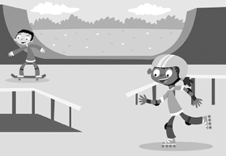 | 1 A ☐ wildlife park  B ☐ skate park
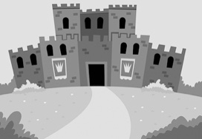 | 2 A ☐ castle  B ☐ adventure playground
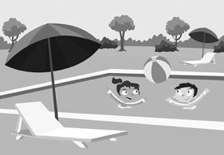 | 3 A ☐ swimming pool  B ☐ bowling alley
 | 4 A ☐ funfair  B ☐ café
/ 4
2 Look, read and circle.
 |  |  |  | 1 snowy / windy  2 foggy / sunny  3 rainy / windy  4 cloudy / sunny  5 snowy / rainy  6 cloudy / foggy
1 | 2 | 3
 |  | 
4 | 5 | 6
/ 6

Grammar
3 Read and tick ().
1 I was … the café on Sunday.
A ☐ at B ☐ on
2 Where … you yesterday? I was at the skate park.
A ☐ was B ☐ were
3 Where were you yesterday? I … at the bowling alley.
A ☐ were B ☐ was
4 I was at the swimming pool … Friday.
A ☐ on B ☐ at
/ 4
4 Look, read and write.
cloudy foggy rainy snowy sunny windy
 |  | 
1 What was the  weather like?  It was . | 2 What was the  weather like?  It . | 3 What was  the weather like?  It .
 |  | 
4 What was the  weather like?  It . | 5 What was the  weather like?  It . | 6 What was the  weather like?  It .
/ 6
Reading
5 Read. Correct the sentences. Change one word.
Dear Diary,
Sunday was a great day! It was sunny and hot. I was at the wildlife park with my brothers. It is a cool place. Lots of animals live at the wildlife park in Toronto. You can go on a small train and see the different animals.
My favourite animals are the monkeys. I know a lot about them. They climb and jump in the trees. They are very funny. They eat nuts and seeds.
They like bananas, too! They’ve got long tails. I like watching the animals at the wildlife park. It was an amazing day!
1 Saturday was a great day.
2 It was cloudy and hot.
3 I was at the wildlife park with my friends.
4 You can go on a small boat.
5 They’ve got long bodies.
/ 5
Writing
6 Rewrite the sentences.
1 Today is Monday
2 I was monkey watching
3 Monkeys are very funny
4 Monkeys eat seeds
5 One monkey has got a hat
/ 5

Listening
7  10 Listen and write the letter.
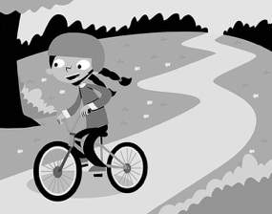 | 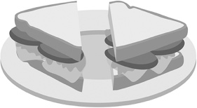 | 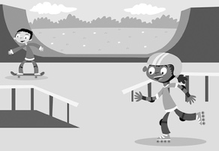 |  | 1  2  3  4  5
A | B | C
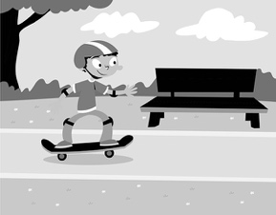 | 
D | E
/ 5
Speaking
8 Look and answer.
What do you want to do at the …
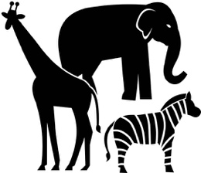 |  |  |  | 1 wildlife park?  2 swimming pool?  3 café?  4 funfair?  5 skate park?
1 | 2 | 3
 | 
4 | 5
/ 5
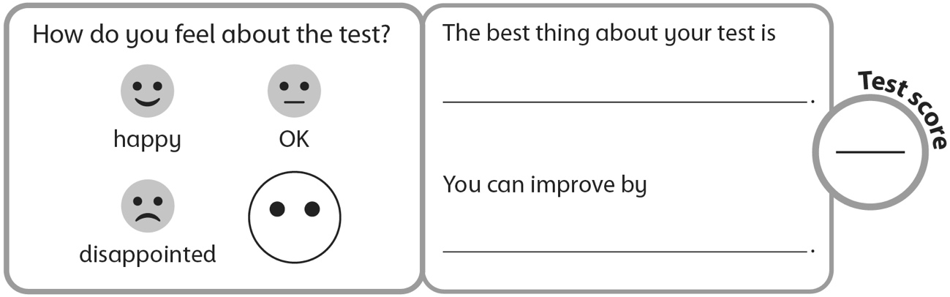
40

